Go and Do
Boro va anjam bede
Luke 10:37

January 15, 2022
The Heart

In Genesis 17:17, Abraham laughed and fell on his face when God told him that Sarah would have a baby at age 90. He doubted God in his “heart.” The word “heart” here means “the center or middle of something.”

“Heart” is used 850 times in the Hebrew O.T. and most of the time it means a man’s or woman’s inner self—the inner core. These are the deepest and innermost feelings.
Wisdom and understanding live or reside in the heart. I Kings 3:12; Proverbs 16:23
Heart of Solomon could also mean his mind. 2 Chronicles 9:23
The heart can perceive or recognize using the senses. 2 Kings 5:26

Well, the heart can also be evil and desperately wicked. Jeremiah 17:9
The heart is stubborn and does not listen to Yeshua. Jeremiah 16:12

When believers don’t obey what Yeshua commands—it’s because of a stubborn heart. We know what is the right thing to do, we just don’t do it.

Sharing Yeshua and making disciples?
“I’m too busy right now.”
“I don’t like those kinds of people.”
“I’m not good talking to people.”
“I don’t have a lot of experience sharing Yeshua.”
“It’s not my job—not my calling.”

All of those reasons for not obeying and making disciples come from a stubborn heart.
We sin. Our hearts are not right with Yeshua. What can we do? Psalm 119:9-11.

Everything we do as believers has its origin in our hearts. What does your heart look like?
Go and Do/2

Underground Observations
The believers in the underground churches were taught about the Magi—and that the wise men came from Iran and Iraq.
Their thoughts:
“If Yeshua wants to guide someone, He will use any way and every way.”
“If you have everything in the world but Yeshua, you don’t have anything.”

Underground House Calls
Our goal is to share the podcast “Underground House Calls” with as many people as possible. We have exciting episodes that feature testimonies of underground believers:
Mozhgan, Alborz, Roya https://bit.ly/32Cd48M
Amir, Behnaz, Kayvan https://bit.ly/3JGBAGl
Lili, Mona, Noor https://bit.ly/3feeABa
The podcast can be found on Apple Podcasts, search for “Underground House Calls.” It can also be found online at: https://faithisidentity.com/go-and-do/

Christmas Boxes 2021
Our second-biggest project of 2021 is now complete, and it was a marvelous success! Our two house churches delivered 16 food and gift boxes. These boxes went to two types of recipients: those who were quietly celebrating their first Christmas as new believers in the true God, Yeshua, and those who have already had a few contacts from our churches and will soon be hearing that there is a God who really does see them and hear their pleas for help. The food boxes included staples that are beyond the reach of these families: chicken, oil, rice, beans, pasta, tomato paste, and more yummies! Gift boxes included items such as winter coats, gloves, hats, boots, school items, and toys. Thank you to everyone for supporting this project; in all honesty, it never would have happened on this scale if it hadn’t been for your generous giving. We wish you could all see the excitement on the faces of our church leaders as they tell us about the shopping, packing, and delivering of these boxes. They feel so blessed to be working together with all of you as the hands and feet of Jesus.

Go and Do/3

Now Ruz Boxes 2022
And now on to our biggest project of 2022: the Now Ruz boxes! Some of you have been partnering with Go and Do long enough now that you understand very well how this all works. Isn’t that a great feeling? For our newer friends, here’s a brief run-down: Now Ruz is the New Year in Iran, and it coincides with the first day of spring. It is a cultural holiday, not an Islamic one. Iranians celebrate Now Ruz on a scale similar to our Christmas and New Year’s holidays. This is a 13-day celebration in Iran; schools close, businesses close, and the people play! In the happiest of circumstances, there are neighborhood and family parties with much singing and dancing; there is Chaharshanbe Suri, when people jump over fire (yes, they call this fun in Iran!); and Sizdah Bedar, a day of outside games and picnics.
However, Go and Do ministers primarily to people who cannot afford to take part in these fabulous celebrations. Church leaders in Iran delight in delivering food boxes to these people during this time, and it has proven to be an excellent outreach opportunity over the years. Last year, our two churches delivered over 30 boxes, and they were part of a much larger effort that delivered well over 400. After these boxes are delivered, our leaders will spend the rest of the year sowing love and kindness and sacrifice to help others, then tell them there is a God who loves them and that Jesus is so much more than the prophet they’ve heard about, and finally show them how to let God change their hearts and their minds; the churches you support will be reaping fruit for God in 2022.
**Please note: we will be sending our gift to Iran for Now Ruz boxes on March 1, 2022.

Now Ruz
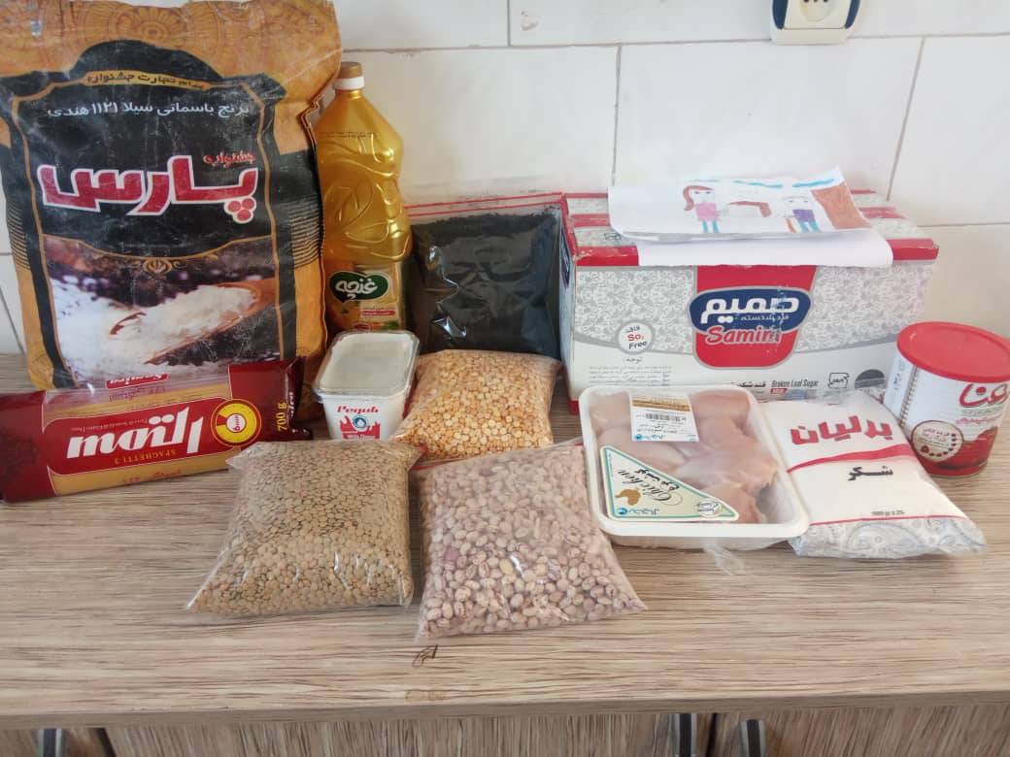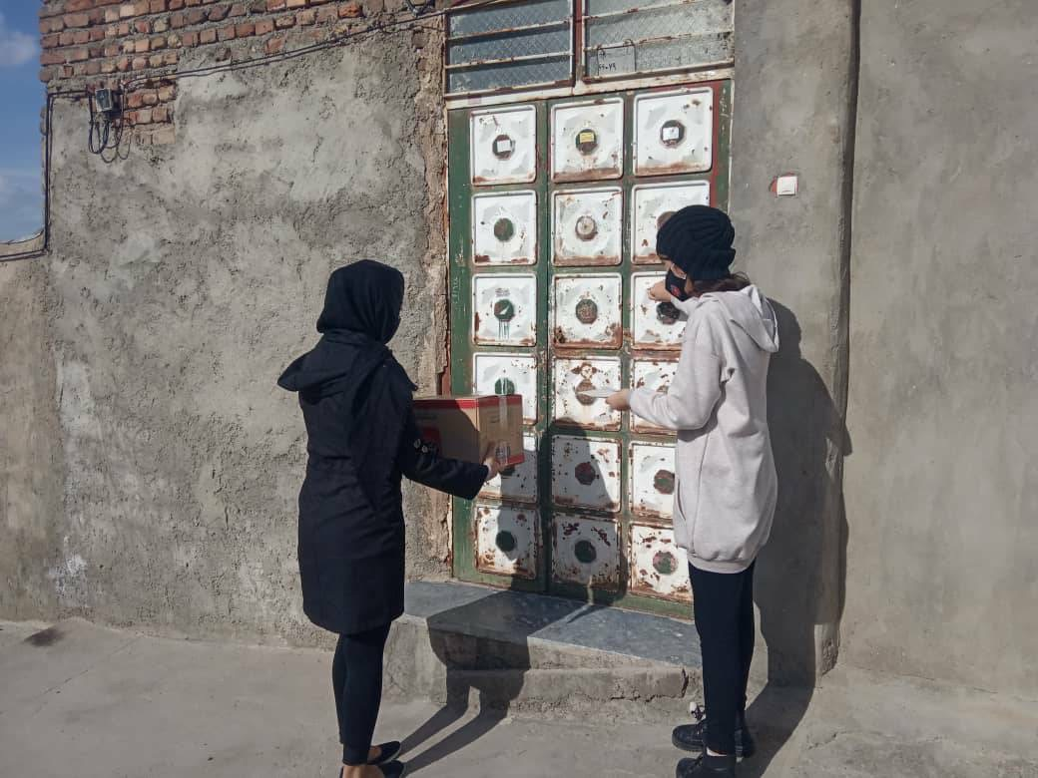

Go and Do/4

Financial Statement
Starting balances 12/16/21:
- General Fund: $44.50
- Christmas Project 2021: $0.16
- Now Ruz Boxes 2022: $475.15
- Conferences: $85.00

Activity 12/16/21-1/15/22:
- Funds Received: $800
- Funds Disbursed: $720
- Iran: $705
- Podcast: $15

Ending balances 1/15/22:
- General Fund: $44.50
- Christmas Project 2022: $40.16
- Now Ruz Boxes 2022: $515.17
- Conferences: $85

We thank you for the love and support you have shown to the people of Iran and most of all for your prayers for them. We pray for you—that you would Go and Do as God directs in your lives and that as a result, you would find intimacy with Him like you have never known before.

Please feel free to let others know they have an opportunity to join us as we Boro va anjam bede. Go and Do.

Kraig and Celeste Ehm
kraig.ehm@gmail.com
celeste.ehm@gmail.com

Go and Do
P.O. Box 386
Laingsburg, MI 48848

