Go and Do
Boro va anjam bede

December 15, 2021

The Magi

In Matthew 2:1-12 we read about the visit of the wise men to Joseph, Mary and baby Yeshua. The word Magi comes from Greek word meaning “one of a learned and priestly class” and the Persian word used to describe them is “mogue” or “magician.” In the ancient Middle Eastern world these Magi were trusted advisors to kings, were learned men proficient in the knowledge of mathematical calculations, astronomy, medicine, astrology, chemistry and philosophy, dream interpretation and history. They even practiced magic.

The Magi in the Bible came “from the east.” The East at the time of Christ’s birth meant Media, Persia, Assyria and Babylonia, countries now encompassed by Iran and Iraq.
What’s amazing is that the prophet Isaiah (Isa. 60:3&6) predicted the Magi would visit.

The magi showed up in Jerusalem and were looking for a boy born “King of the Jews.”
“We saw His star where we lived and want to worship Him.” Notice “King” and “Him.” The Magi had reverence and respect for young Yeshua. King Herod is scared. Everyone is scared. Herod wanted to know when and where the Christ was going to be born--so he brought the chief priests and scribes, you know, the religious Jews. The religious folks quote Micah 5:2. King Herod secretly sends the Magi to Bethlehem to find the “Child.” Not “a child” but “the Child.”

The Magi leave King Herod. As they travel they see the same star they saw in the east.
The star went on before them. The star was sent from God and was leading them. The Magi were thrilled to see the star because they knew God was leading them.

The Magi came into the house. Yeshua is now about two years old. They see the Christ (Yeshua), fall down and worship Him.

As believers, every day we are in the presence of Yeshua. Do we fall down and worship Him like the Magi?

You can have all the degrees in the world. You can be the smartest person in the world. But if you are not following and bowing down to Yeshua, you have studied all of those years for nothing.
Go and Do/2

Underground Observations
This section includes thoughts from the underground church in Iran. We hope you receive as much of a blessing out of reading it as we have from hearing the spoken words from our fellow believers.

Thanksgiving is the act of giving thanks; grateful acknowledgement of benefits or favors, especially to God. Their thoughts:
“God gave me power to be powerful—He brought me from a worse situation and I am His.”
“God guides us with His word. He has put us in the light.”
“I’m thankful for the things God gives me. I count everything once, but my mom is the best thing God gave me.”
“Yeshua chose me not to be a slave, but to be free. He gave me value.” (from a church leader who is a woman)
“God chose me to show His light to others.”

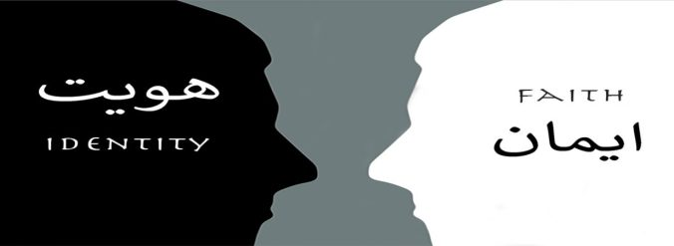

faithisidentity.com
Our website contains content in Farsi and English. “Faith is Identity” features several testimonies from underground believers in Iran, the books of Matthew and John, encouragements which are chapters in the Book of Psalms—and it is all in Farsi. The “Go and Do” section is in English and has newsletters and Underground House Calls--a new podcast that features stories, teaching and testimonies of people who are spreading the Good News of Jesus. Be sure to catch the two-part interview with a former Muslim that converts to Christianity. The podcast can be found on Apple Podcasts, search for “Underground House Calls.” It can also be found online at: https://faithisidentity.com/go-and-do/

An exciting podcast episode features the testimonies of underground believers Shirin, Mina and Nasrin. All three have been recorded in English: https://bit.ly/3Dzf9PD

Go and Do/3

Teamwork
We recently shared Go and Do with a group of college-age folks, and they responded by helping with English and recording testimonies.

Now Ruz?

The people of Iran are near and dear to our hearts. We are working with believers there to shed light in a dark world, but before the name of Jesus can be shared, the Iranian people have practical needs that must be met. The following is a list of some of the ways the Go and Do team members in the U.S. have been a blessing to Iran thus far in 2021 as the believers set out to make disciples:

- Food
- Housing
- Clothing
- College tuition and textbooks

- Dental work
- Medical and hospital bills
- Room fans in extreme heat
- High school uniforms and supplies
__________________________________________________________________________

Financial Statement
Starting balances 7/16/21:
- General Fund: $175
- Christmas Project 2021: $375.05
- Now Ruz Boxes 2022: $375.05

Activity 7/16/21-10/14/21:
- Funds Received: $3325
- Funds Distributed: $3231
- Iran: $2920
- Christmas Project 2021: $92.50
- Now Ruz Boxes 2022: $92.50
- Podcast: $21
- Conference Room Reservations: $105

Ending balances 10/14/21:
- General Fund: $269.50
- Christmas Project 2021: $467.61
- Now Ruz Boxes 2022: $467.61

**gifts may be earmarked for any project if desired
**checks payable to Kraig or Celeste Ehm
** PayPal to @celesteehm

We thank you for the love and support you have shown to the people of Iran and most of all for your prayers for them. We pray for you—that you would Go and Do as God directs in your lives and that as a result, you would find intimacy with Him like you have never known before.

Please feel free to let others know they have an opportunity to join us as we Boro va anjam bede. Go and Do.

Kraig and Celeste Ehm Go and Do
kraig.ehm@gmail.com P.O. Box 386
celeste.ehm@gmail.com Laingsburg, MI 48848

