Go and Do
Boro va anjam bede

October 15, 2021

Jesus is the Great Light.

The prophet Isaiah predicted the birth of Jesus in Isaiah 9:1-7. Isaiah lived 150 years before King Cyrus (When teaching Iranian believers the Old Testament, we reference people and events in relation to Cyrus, the Persian king). In verse 1, Isaiah repeats chapter 8. Israel is awful. Israel has rejected God again. Surprise.

Zebulun and Napthali suffered under Assyrian invasion. This verse mentions Galilee (this is important). In verse 2, to the people who had walked in darkness (all of Israel), God made a promise of a great light. In Matthew 4:14-16, Matthew repeats what Isaiah wrote. Jesus is beginning his ministry in Matthew 4:12 and He is the great light.

In Isaiah 9:4, “Thou” means The great light will break the yoke of their burden and the staff on their shoulders. “Yoke” is a device for joining together a pair of draft animals, especially oxen, usually consisting of a crosspiece with two bow-shaped pieces, each enclosing the head of an animal. The great light (Jesus) broke our yoke of burden. What is weighing you down? What is causing you worry? Jesus took that away. In this verse, the Prophet Isaiah also reaches back in history and brings up Gideon in Judges 6-7. Here, Gideon achieves a miraculous victory by the power of God—and Isaiah informs his readers that the Great Light will cause them to be victorious, just like Gideon.

In Isaiah 9:5, The great light will one day stop all wars.
In Isaiah 9:6, Isaiah uses language to say the Messiah was already born! They call this tense Prophetic tense. “For a child will be born to us, a son will be given to us.”
In 9:6, a child is born--son is given. This child has four names: Wonderful Counselor, The Mighty God, The Eternal Father and the Prince of Peace.

At Christmas, we sometimes think of a baby being born in a manger. But it was so much more than that.

Jesus came to earth as the Great Light.

Go and Do/2

Underground Observations
This section includes thoughts from the underground church in Iran. We hope you receive as much of a blessing out of reading it as we have from hearing the spoken words from our fellow believers.

Samson—Biblical Man of Steel with the Beautiful Head of Hair. Their thoughts:
“When God chooses us, it is up to us to finish.” (From a 15 year-old girl.)
“In this world, nothing is worth anything and everything is God’s.”
“Today, are you bent? Kneeling with all your power to ask God? Until you give all, He doesn’t give you anything.”
“God never takes back what He gives us. We lose it because we are unfaithful. We can get it back by being faithful.” (From a 13 year-old girl.)

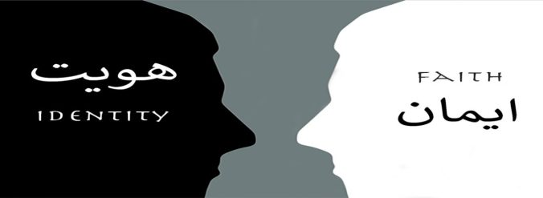

faithisidentity.com
Our website contains content in Farsi and English. “Faith is Identity” features several testimonies from underground believers in Iran, the books of Matthew and John, encouragements which are chapters in the Book of Psalms—and it is all in Farsi. The “Go and Do” section is in English and has newsletters and Underground House Calls--a new podcast that features stories, teaching and testimonies of people who are spreading the Good News of Jesus. Be sure to catch the two-part interview with a former Muslim that converts to Christianity. The podcast can be found on Apple Podcasts, search for “Underground House Calls.” It can also be found online at: https://faithisidentity.com/go-and-do/

Go and Do/3

Teamwork
The people of Iran are near and dear to our hearts. We are working with believers there to shed light in a dark world, but before the name of Jesus can be shared, the Iranian people have practical needs that must be met. The following is a list of some of the ways the Go and Do team members in the U.S. have been a blessing to Iran thus far in 2021 as the believers set out to make disciples:

- Food
- Housing
- Clothing
- College tuition and textbooks

- Dental work
- Medical and hospital bills
- Room fans in extreme heat
- High school uniforms and supplies
__________________________________________________________________________

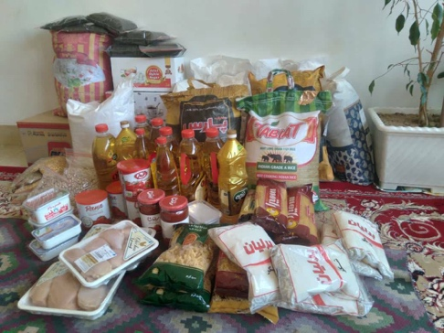 Christmas Boxes!

Go and Do is in constant motion. All year long, the disciples in Iran are meeting new people and becoming better acquainted with others, all while focusing heavily on yet other groups that are ready to leave their hopelessness behind and embrace Jesus. At this time of year, we are making final preparations to send funds to Iran so the disciples there can deliver Christmas care packages to people living in dire circumstances. This is a critical step in the process of becoming better acquainted with new friends, showing them the love of Jesus, and gaining their trust. Last year, our two churches delivered 31 boxes. They are excited about this year and hope to bless even more people this time. If you would like to be a part of this awesome event, please keep two things in mind: we will send funds to Iran on December 1, and there is no such thing as an excess of funds! Every dollar that is given will be used to feed and clothe Iranians who cannot feed and clothe themselves adequately.
Go and Do/4

Fall Conference
Our Fall Conference is quickly approaching, and we hope to see many of you there! We’re expecting a full day of truth and hope as we bring our hearts and minds together with the leaders from the underground church in Iran. If you have not yet indicated to us that you’d like to attend, we still have some seats available. Please see the attached schedule for the conference and then rsvp with a reply to Kraig at this email if you haven’t done so already.

Financial Statement
Starting balances 7/16/21:
- General Fund: $175
- Christmas Project 2021: $375.05
- Now Ruz Boxes 2022: $375.05

Activity 7/16/21-10/14/21:
- Funds Received: $3325
- Funds Distributed: $3231
- Iran: $2920
- Christmas Project 2021: $92.50
- Now Ruz Boxes 2022: $92.50
- Podcast: $21
- Conference Room Reservations: $105

Ending balances 10/14/21:
- General Fund: $269.50
- Christmas Project 2021: $467.61
- Now Ruz Boxes 2022: $467.61

**gifts may be earmarked for any project if desired
**checks payable to Kraig or Celeste Ehm
** PayPal to @celesteehm

Go and Do/5

We thank you for the love and support you have shown to the people of Iran and most of all for your prayers for them. We pray for you—that you would Go and Do as God directs in your lives and that as a result, you would find intimacy with Him like you have never known before.

Please feel free to let others know they have an opportunity to join us as we Boro va anjam bede. Go and Do.

Kraig and Celeste Ehm Go and Do
kraig.ehm@gmail.com P.O. Box 386
celeste.ehm@gmail.com Laingsburg, MI 48848

